ELDP TDC1 Fall – Controls
Supporting Documentation
Team Carpe Noctem
Carlos Lazo, Christopher Rappa, Michael Sangillo, Jake Tisdale
December 23, 2008

Controller Requirements:

The unit-step system response shall:
- Have less than 20% overshoot.
- Settle within 2% of its final value in 0.6 seconds.

Initial System:

The given Laser Guided Missile system did not meet the requirements as specified. Figure 1 shows that the overshoot (42.09%) for the original system exceeds the requirements limit of 20%. Its settle time is ~5.25 seconds.

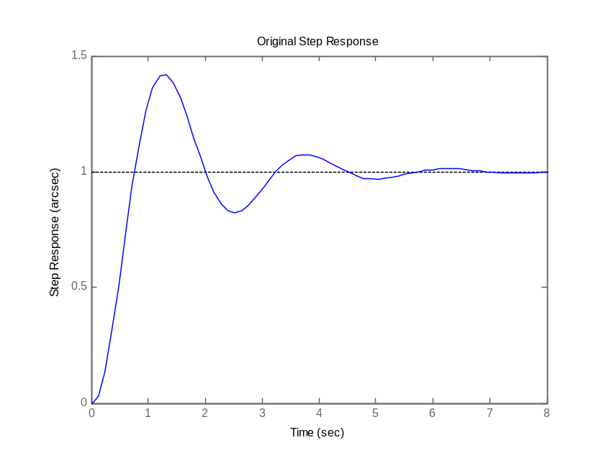
Figure 1: System Response to a Unit Step

Figure 2 shows the root locus for our original system. This allows us to see that there are no reasonable gains that will yield a stable response with our timing and overshoot restrictions. The stable gain regions are too far from the complex axis.
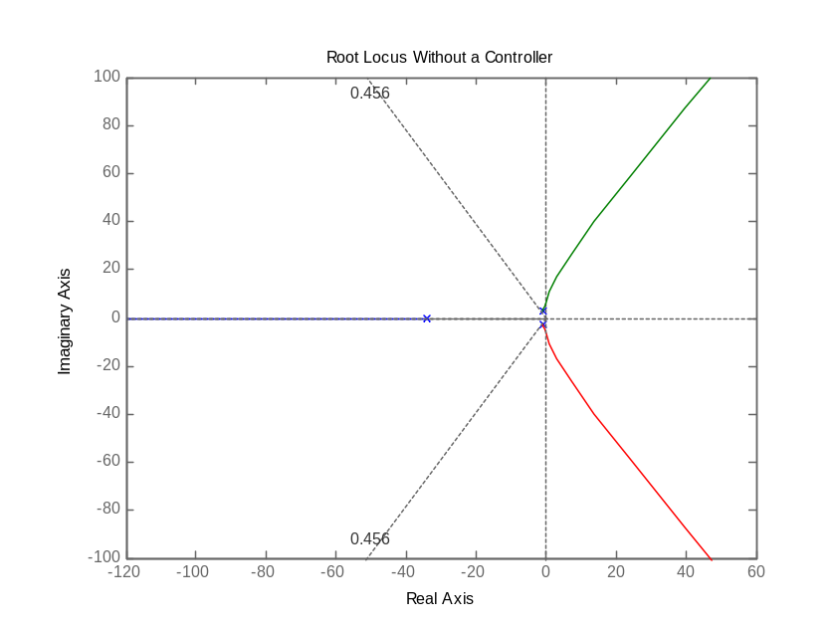
Figure 2: Original System Root Locus

Figure 3 shows that we have high frequency attenuation in the original system. Our controller must counteract this attenuation to make sure that our operating high frequency content needed for a fast response is passed through.

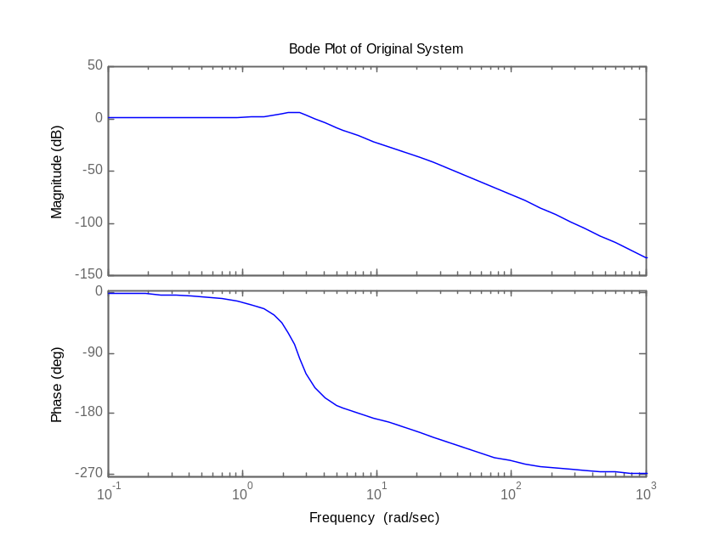
Figure 3: Original System Bode Plot

Criteria:

To start, Carpe Noctem decided to create a list of criteria that would help to define success once the final product was created.

We determined that the missile must:
- Minimize for Cross Coupling error
- Have less than 20% overshoot
- Settle within 2% of its final value in 0.6 seconds.

Missile Targeting Definition:

To begin, we decided to use the elevation fins to adjust for the elevation error. Horizontal azimuth correction will be handled by the elevation fins as the missile rotates.

Missile Elevation θ_{e}
Missile Azimuth θ_{a}
Received Energy
Missile Fin in
Elevation Position
Missile Fin in
Azimuth Position
θ_{a}
θ_{e}
Missile Rotational
Direction θ
Figure 4: Missile Coordinate Orientation

Cross Coupling Analysis:

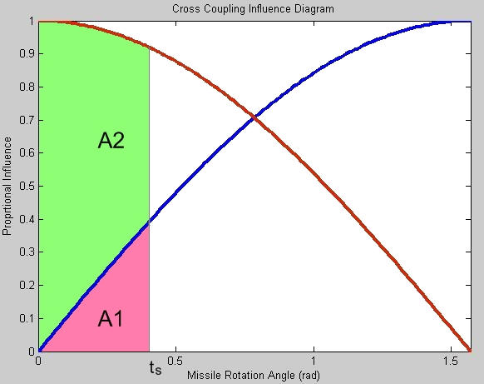
Figure 5: Cross Coupling Influence Diagram

We defined cross coupling as the contribution to the orthogonal axis correction as we attempt to correct for elevation only. As the missile rotates, the elevation fin corrections begin to contribute more to azimuth. To calculate the value for cross coupling we chose to compare the contribution curves of elevation and azimuth, as shown in Figure 5. We use the influence ratio, defined by the division of the elevation influence into the azimuth influence with respect to the rotation angle of the missile. We multiply this by the error seen with respect to time. A definite integral quantifies the total cross coupling over a specified time interval. Our time interval is from zero to the sample time.

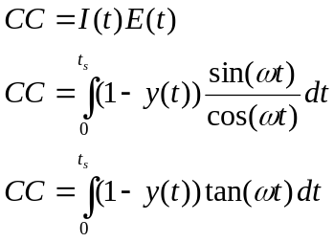 Equation 1: Cross Coupling

To ensure that our control system would always contribute, at least, two times more to the elevation correction as azimuth, we set our influence ratio to ½. The threshold represents the ratio of the horizontal fin contribution in elevation over azimuth, which defines how far the missile can rotate before needing to resample and realign its elevation/azimuth axes.
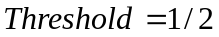

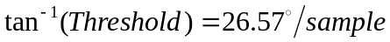

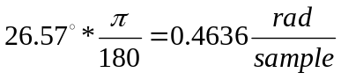
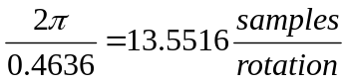

Now we know that the missile cannot rotate for more then 26.57 deg (0.4636 rad) between samples. We can calculate our missiles angular frequency using this sample angle. However, we still need to calculate our ideal settle time.

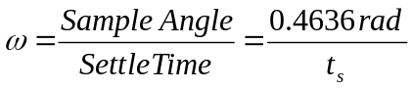

Controller Design:

From the original system’s root locus, we know that a P controller will not give us the results we need. Figure 6 shows this. As we increase Kp, our rise time is decreased, but we experience overshoot and experience little of the change we need in settle time.
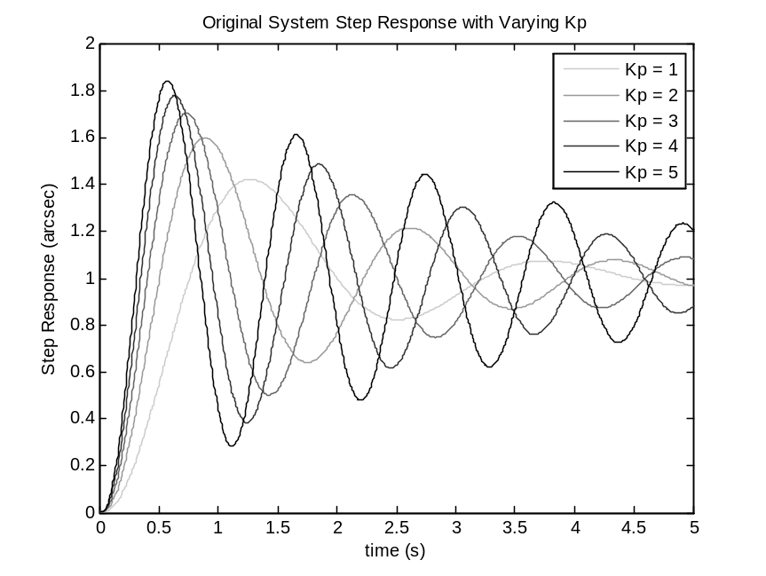
Figure 6: Varying Kp P Controller Step Responses

When we added a differential term, our results greatly improved. Figure 7 shows that with experimental values, we can meet our criteria.
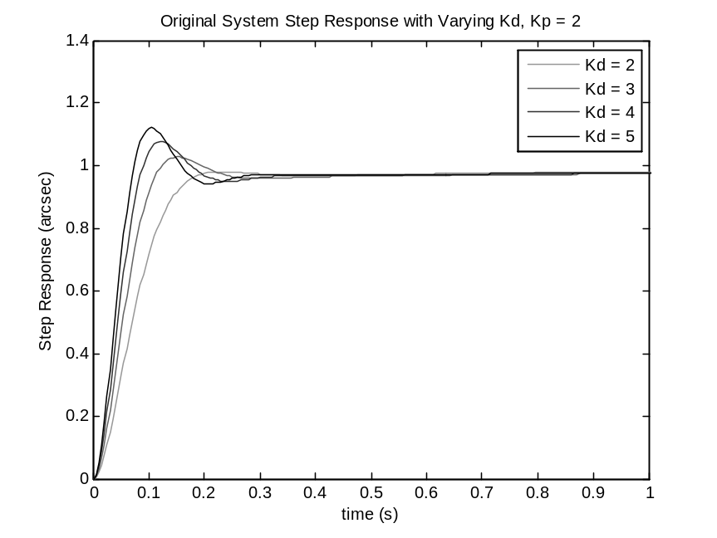
Figure 7: Varying Kd PD Controller Step Responses

Controller Optimization:

Now that we know that a PD controller meets our criteria, we can now optimize the gains. We did this by scripting an automatic PD tuning algorithm. We coded this algorithm to examine all combinations of Kd and Kp over a specified range. The algorithm weighed the step responses against our criteria, and assigned points based on whether or not the gains met our Criteria. Figure 8 shows the gain ranges with the points assigned to our passing criteria.

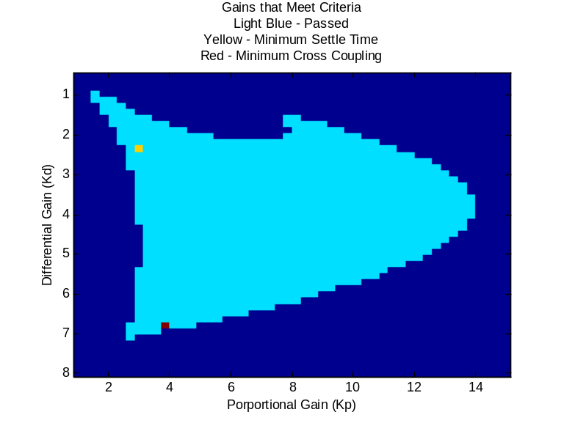
Figure 8: Valid PD Gain Outputs

We now have an estimate for the region where the minimum cross coupling gains are located. If we run the algorithm again in this range, we can increase the precision of our gains and further minimize the cross coupling of our system. Figure 9 shows the zoomed gain region and the points associated with the pass.

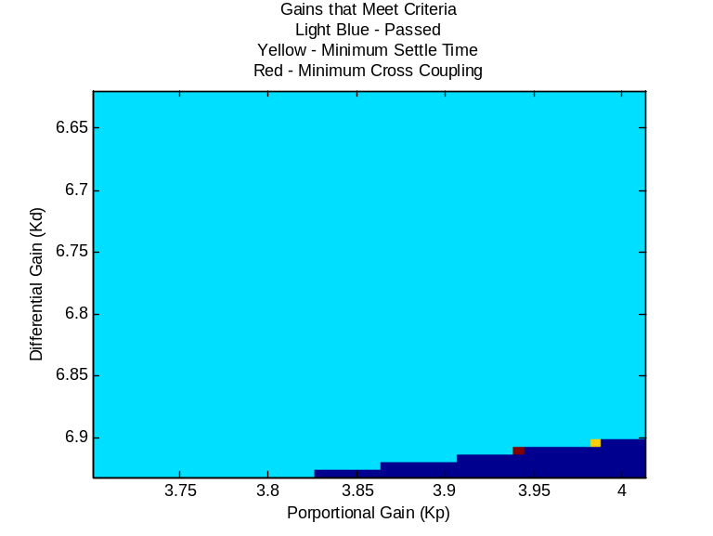
Figure 9: Zoomed Valid PD Gain Outputs

Our ideal values are Kd = 6.9098 and Kp = 3.9415. By inputting the Kp and Kd values into the PD controller, we can determine exactly how our controller matches up against our criteria. Figure 10 shows the system response to a unit step input. Our settle time is 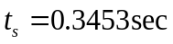. We have an overshoot of 19.9979%.

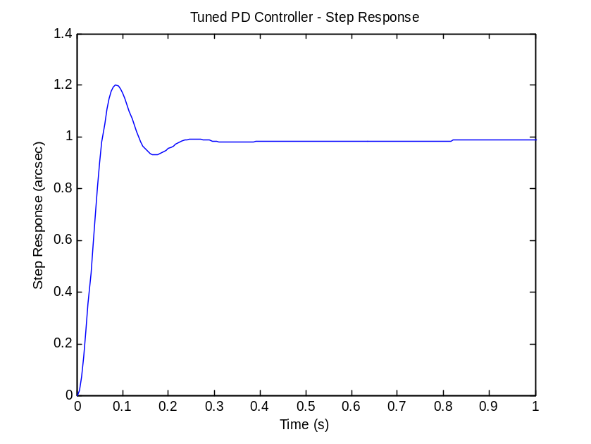
Figure 10: Output Results with New PD Controller

Now we can calculate the speed the missile rotates at because we know the amount we want it to rotate for one sample and the time it takes one sample to reach steady state.
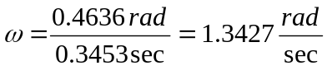

We now can also calculate for the frequency we want the laser to fire at, which will give use one sample every 0.3453 sec.

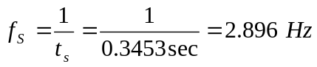

Figure 11 shows our new system’s root locus. We have brought the poles of the system much closer to the complex axis and the system speed has increased. In addition, we can see that the poles are located right on the zeta lines. That means that our proportional gain is perfectly tuned to the upper limits of our overshoot criteria.
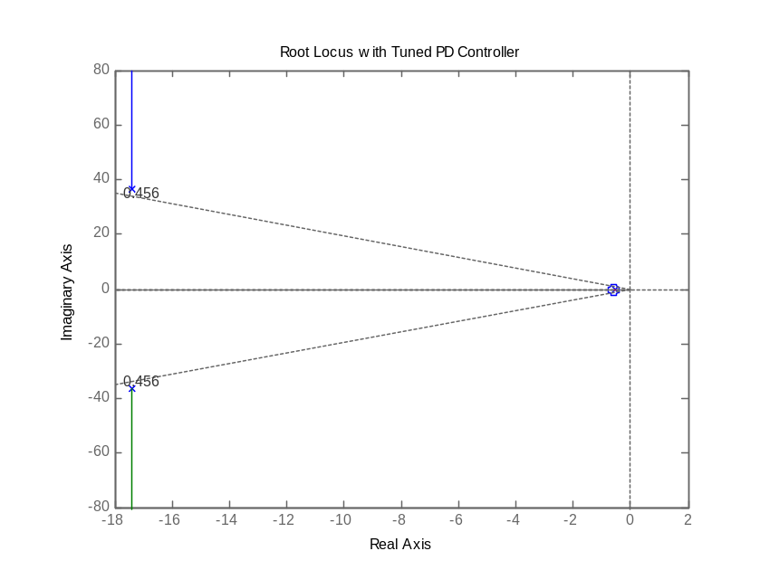
Figure 11: Controlled System Root Locus

Figure 12 shows that we have significantly decreased the high-frequency attenuation.
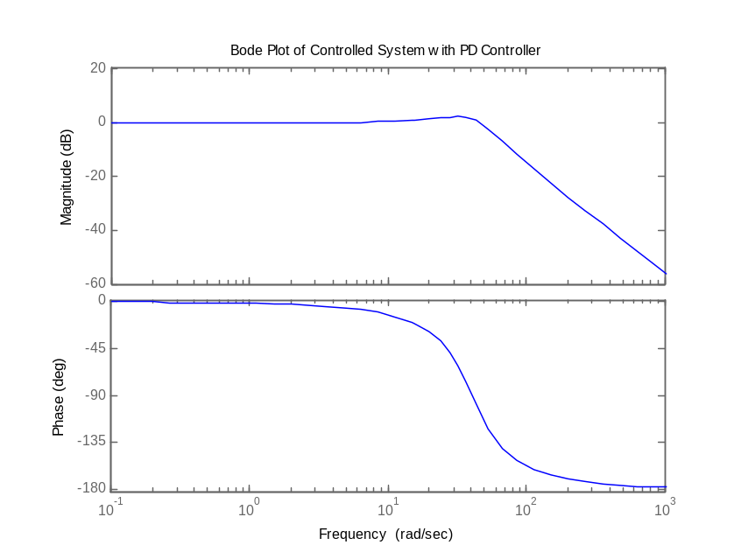
Figure 12: Controller System Bode Plot

Actual Controller Design:

Now we need to solve for a hardware fix, not just an output in MATLAB. We decided to go with an inductor and resistor PD controller because they are inexpensive and easy to make with COTS parts. We could also implement this with a simple op-amp circuit. We started by solving the transfer function of an LR controller as shown in Figure 13.

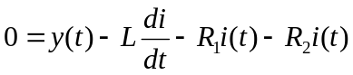
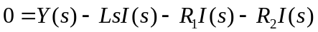
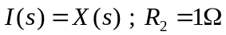
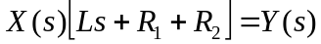
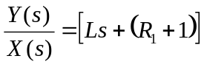
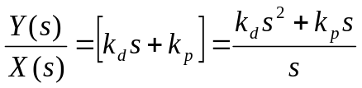

Because MATLAB was setup to solve for the controller, we now need to fix the system that will match the values found: k_{d}=6.9098 and k_{p}=3.9415.

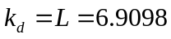
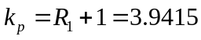
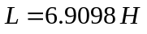
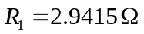
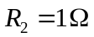

This leaves us with the following controller to which simply needs to be added after the “servo amplify” and before the “servo and brake” portion of the entire control system.

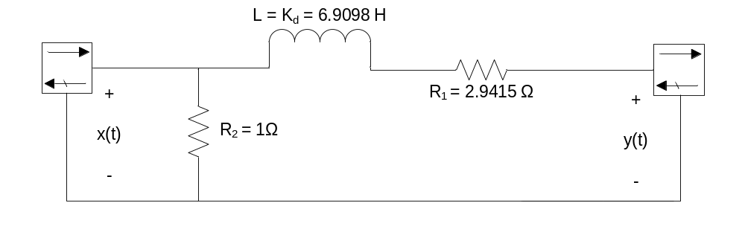
Figure 13: PD Controller

Simulated Input:

In Figure 14 we tried to show what a typical operational input would look like. The input to the system was a series of decaying steps at intervals equal to our pulse sample frequency. This graph shows that our controlled system follows the discrete input quite well. Our system cannot follow the red sampled dots exactly, but the goal is to follow their rotational paths as they traverse the circle. Obviously, we can’t factor in the environmental response without an accurate transfer function, but we feel like this depiction gives us a good idea on how our system would respond to a typical input.

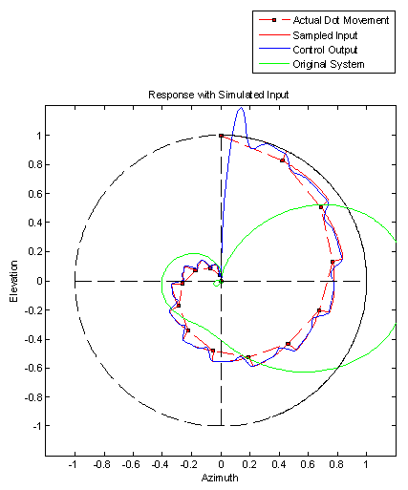
Figure 14: Laser Guided Missile Tracking

